Exercise 16
- List ids, birth dates and emails of employes born in April.
SELECT id, date_of_birth, email FROM employee_data WHERE MONTH(date_of_birth) = 4;
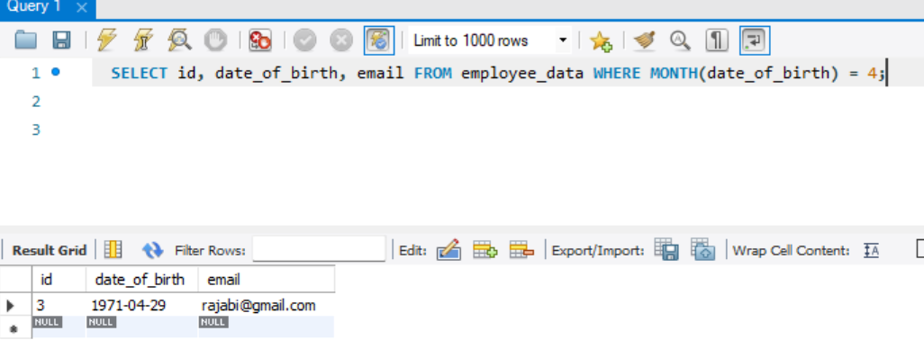
- Display Ids, birth dates and spouse names of employees born in 1969
SELECT id, date_of_birth, spouse FROM employee_data WHERE YEAR(date_of_birth) = 1969 ORDER BY spouse;
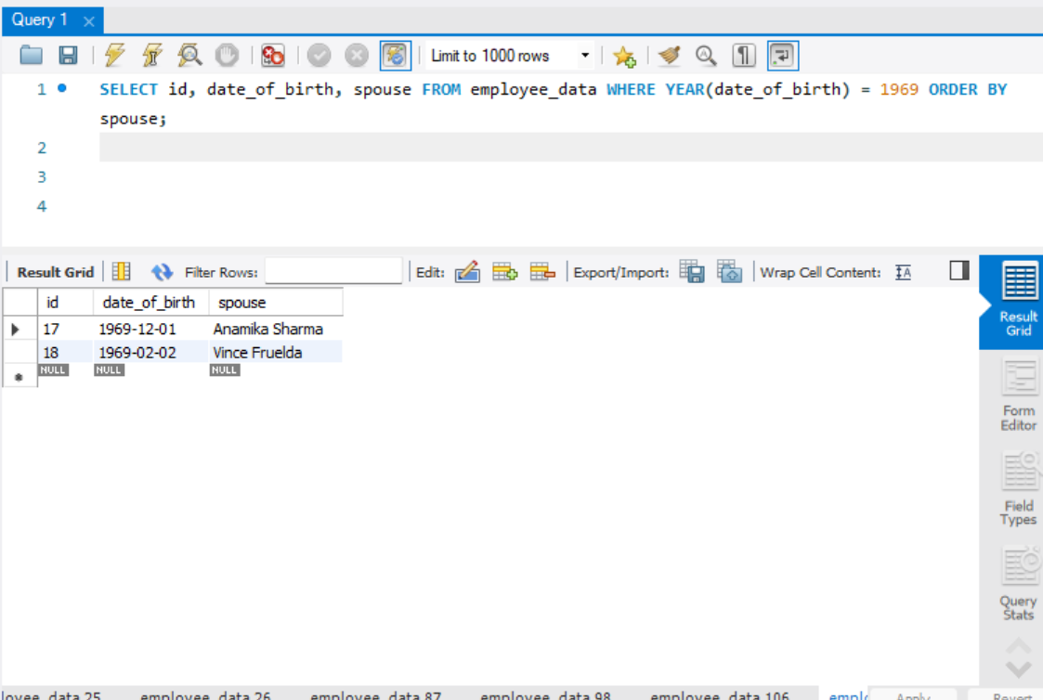

- List the employee ids for employees born under the current month.
SELECT id FROM employee_data WHERE MONTH(date_of_birth) = MONTH(CURDATE());
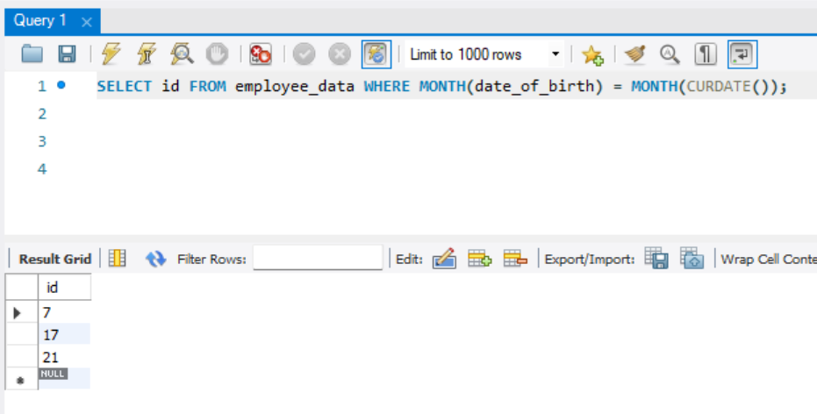
- How many unique birth years do we have?
SELECT count(DISTINCT date_of_birth) AS count FROM employee_date);
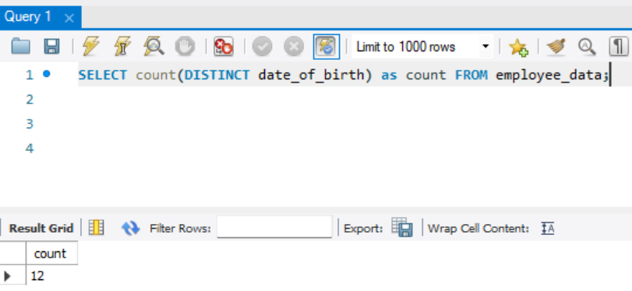

- Display a list of unique birth years and the number of employees born under each.
SELECT date_of_birth, count(date_of_birth) AS count FROM employee_data GROUP BY date_of_birth;
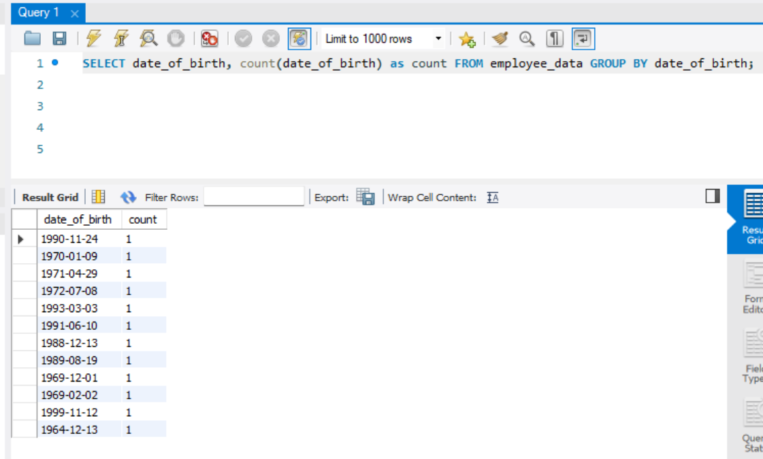
- How many employees were born under each month? The display should have month names (NOT numbers) and the entries should be sorted with the month having the largest number listed first.
SELECT MONTHNAME(date_of_birth) as MONTH, count(date_of_birth) as count FROM employee_data GROUP BY MONTHNAME(date_of_birth) count DESC;
